Python Programming Assignment 1

# Index Page



**Student Information**

* **Name**: [ATUL KUMAR]
* **Student ID**: [590011190]
* **Branch**: [MCA]
* **Batch**: [B1]
* **Instructor**: [**Abhirup Khanna**]
* **Date**: [24/07/2024]



# Assignment Questions

**Question 1: Basic Arithmetic Operations**

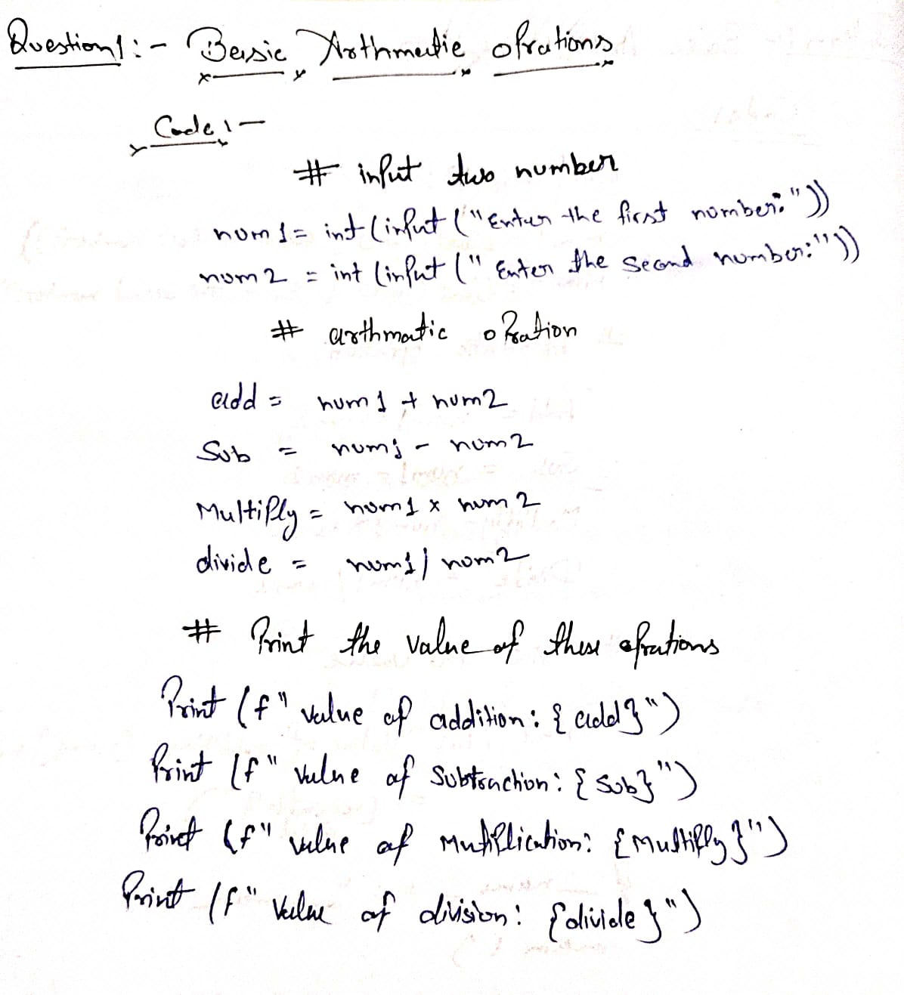**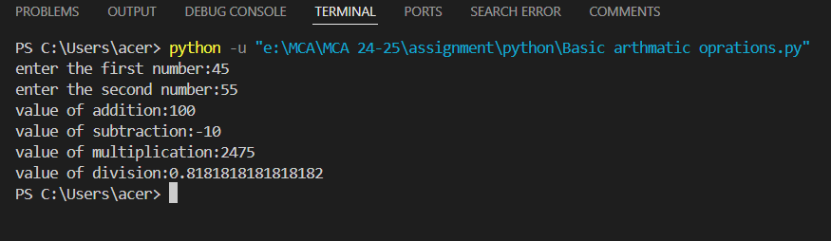Task**: Write a program that performs basic arithmetic operations (addition, subtraction, multiplication, and division) using integers and floats. Print the results.

**Output:-**

# Question 2: String Concatenation

**Task**: Write a program that takes two strings as input, concatenates them, and prints the result.

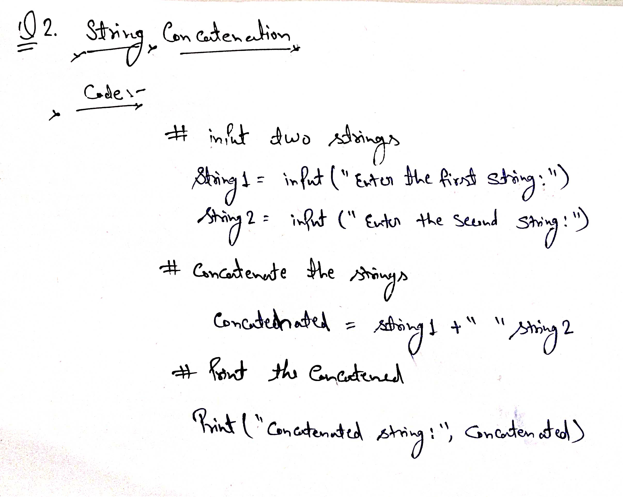

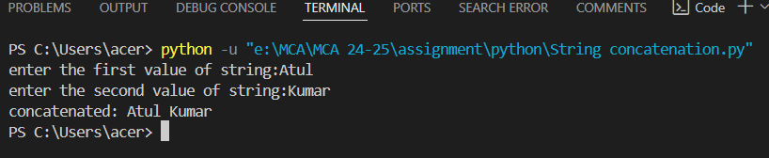

**Output:-**

# Question 3: List Manipulation

**Task**: Create a list of five integers. Replace the third element with a new integer and print the updated list.

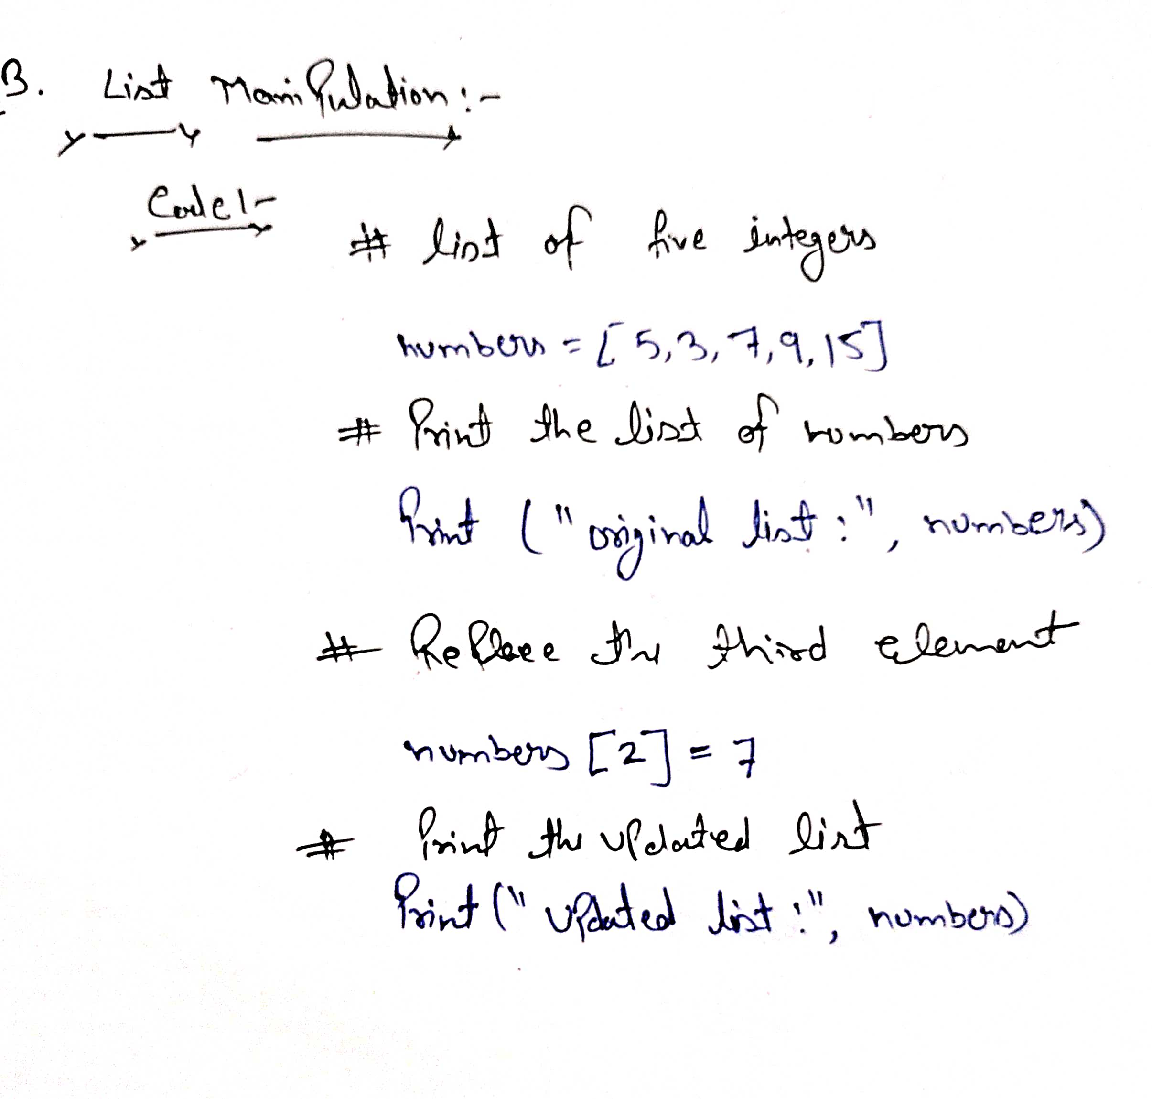

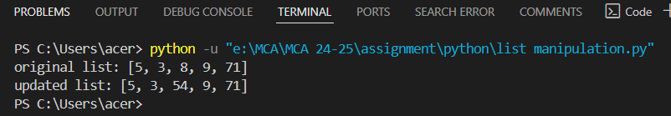

**Output:-**

# Question 4: Array Initialization and Access

**Task**: Initialize an array with five float numbers. Access and print the second and fourth elements.

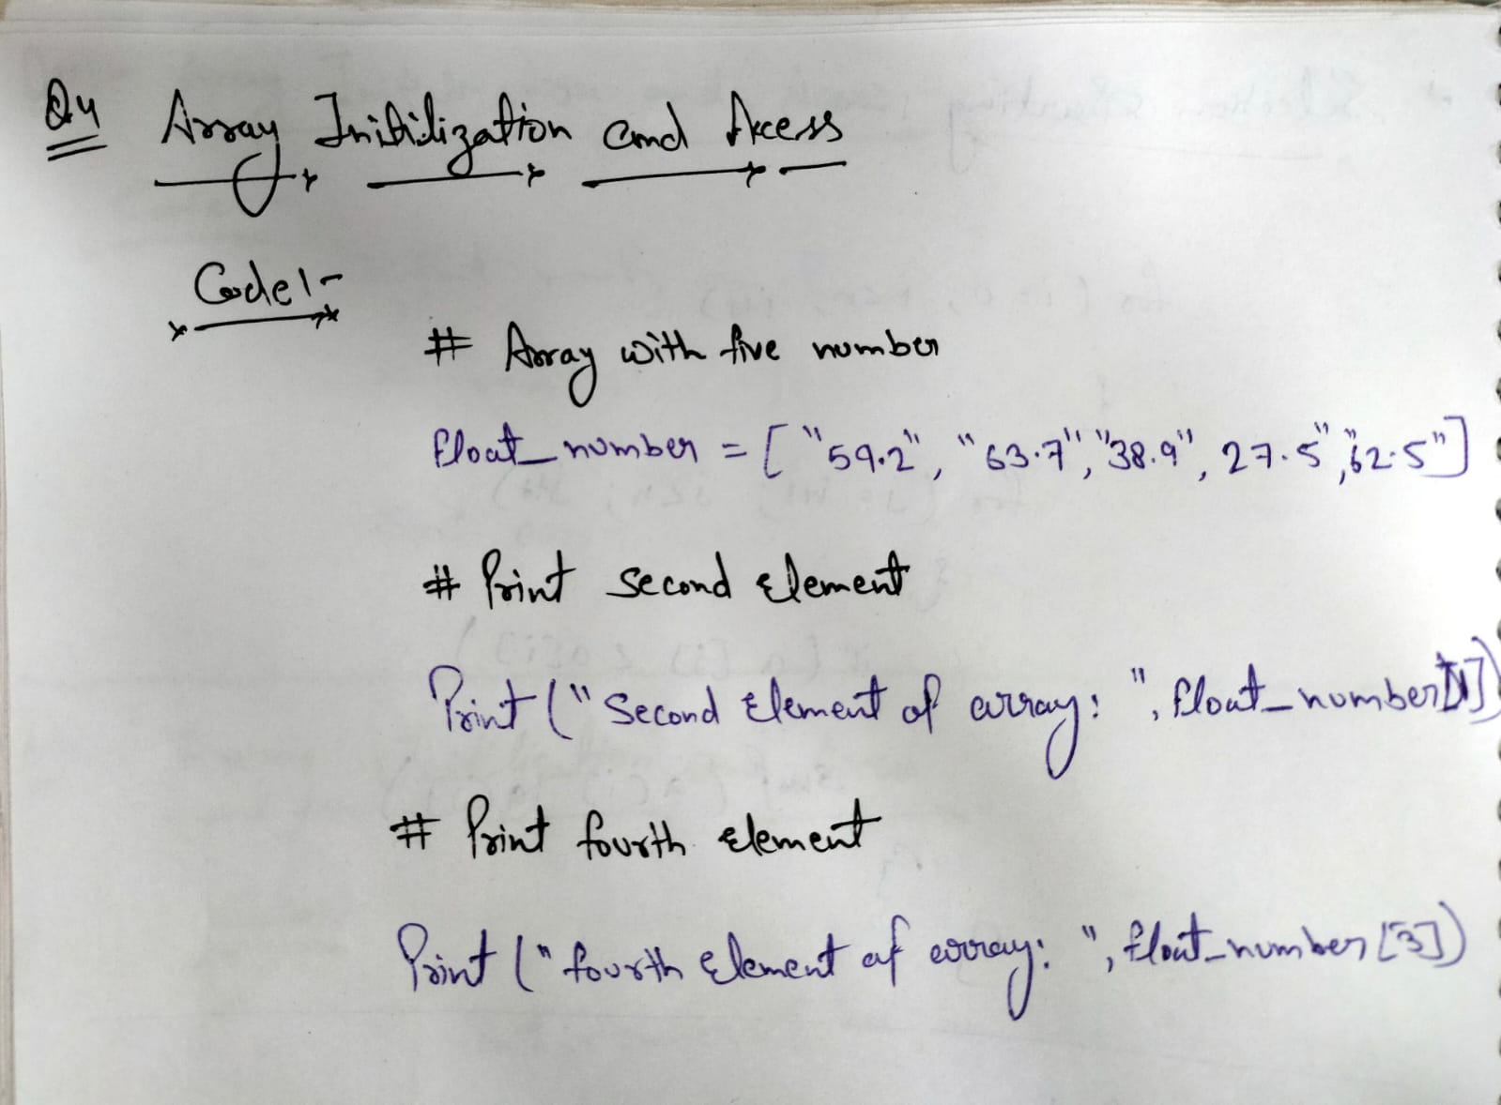

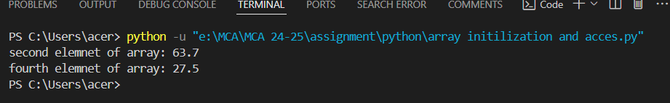

**Output:-**

# Question 5: String Slicing

**Task**: Write a program that takes a string input, slices the first five characters, and prints the sliced string.

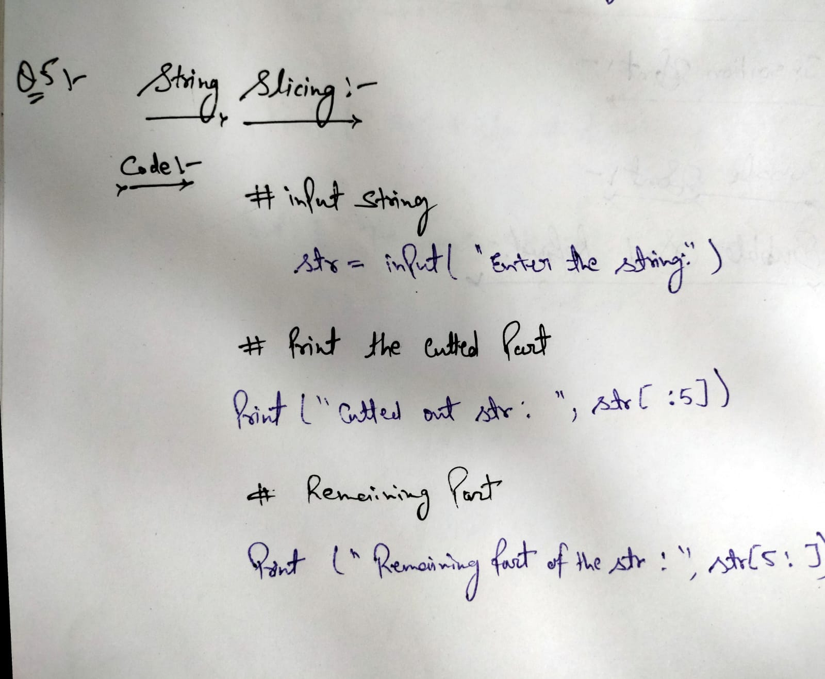



**Output:-**

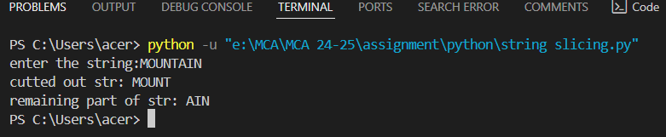

THANK YOU